**Volkswagen Golf MK7.5 Facelift Lane Assist Retrofit**

**PREREQUISITE:** The front lane assist camera uses the extended CAN bus, meaning that you must have the HIGH variant of the gateway. If not you must upgrade it before retrofitting, otherwise it won't work.  
  
IMPORTANT: You must disconnect both terminals of the battery, negative first and then the positive before starting this retrofit!

**Circuit diagram**

[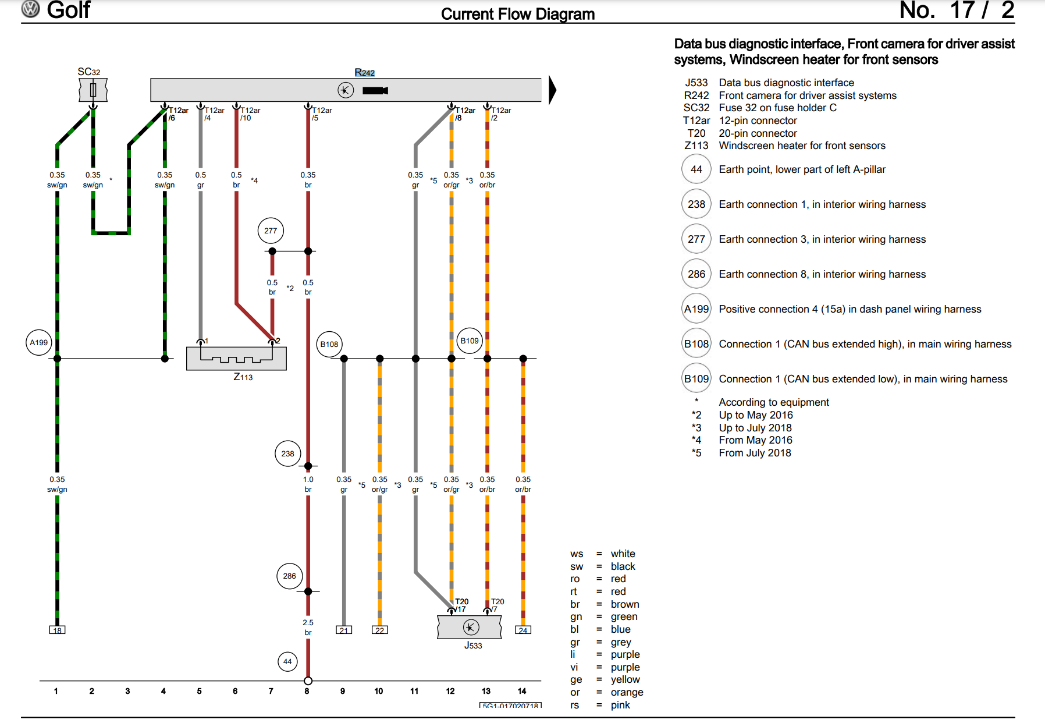](http://redirect.viglink.com/?key=71fe2139a887ad501313cd8cce3053c5&subId=6321844&u=https%3A//i.ibb.co/WxsksnN/image.png)

6 wires to be connected

* The brown for the ground (near the camera on the roof)
* The black/green for the 12V power (in the fuse box on the left side of driver seat)
* A connector with two wires to the heating element installed with the new windscreen
* The orange/gray and orange/brown wire have to be connected to the gateway unit (or the T17d/l black connector). Pin T20/17 and T20/7 of the gateway unit (J533) are also connected respectively to T17d-l/12 and T17d-l/13, you can connect the front camera wiring harness also here (easier)

[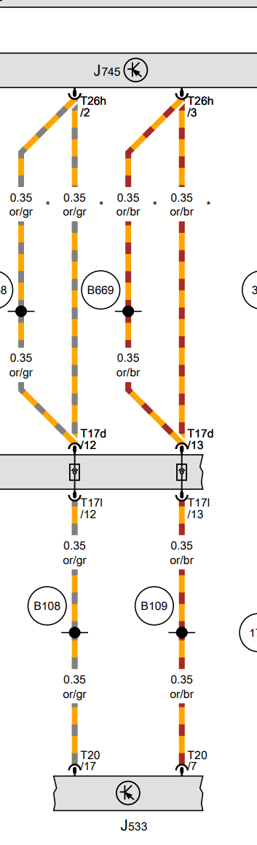](http://redirect.viglink.com/?key=71fe2139a887ad501313cd8cce3053c5&subId=6321844&u=https%3A//ibb.co/DkZ832C)

If you have adaptive cruise control you have to connect 2 additional wires, e.g. the front camera T12ar/7 and T12ar/1 to respectively T8ay/5 and T8ay/6 (R242 is the lane assist camera, J428 is the adaptive cruise control, T8ay is the black connector which plugs into the adaptive cruise control radar)  
  
[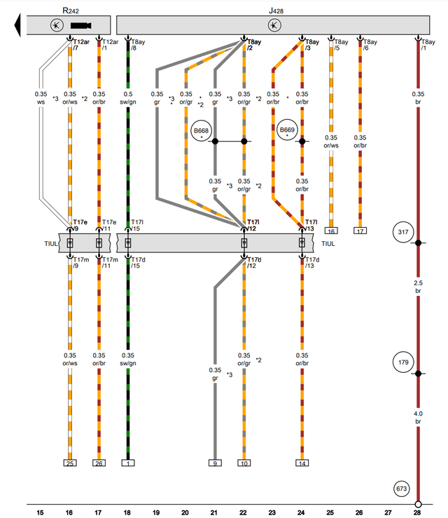](http://redirect.viglink.com/?key=71fe2139a887ad501313cd8cce3053c5&subId=6321844&u=https%3A//ibb.co/grZh42k)

**What you need to buy:**

* A windscreen with camera support, the most complete windscreen is 5G0845011ARNVB which is heated and has both the camera and rain/light sensor support.
* [Wiring harness (https://www.aliexpress.com/item/4001113041051.html)](https://www.aliexpress.com/item/4001113041051.html), there are two versions of the harness, one if you do not have adaptive cruise control and one if you have, the difference is just 2 additional wires.  
  [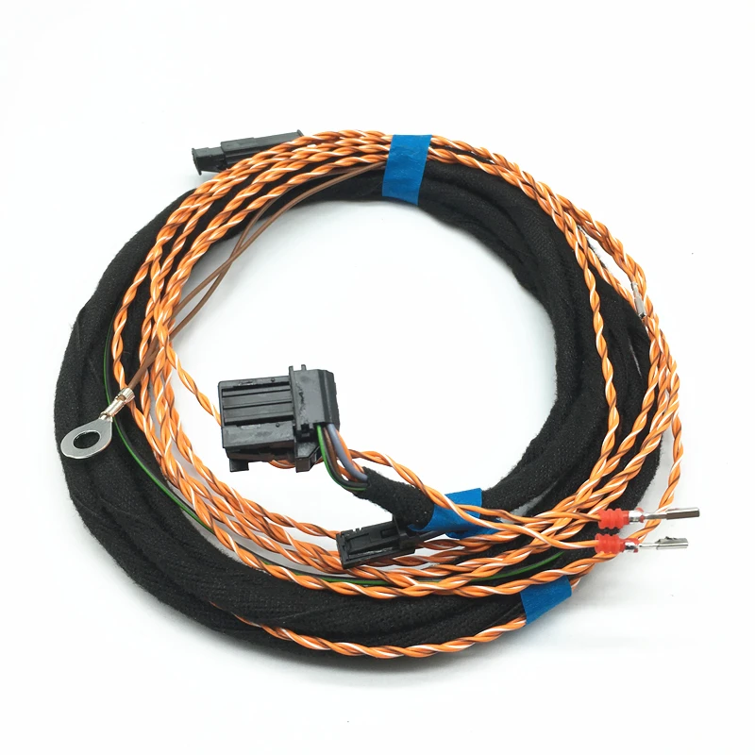](http://redirect.viglink.com/?key=71fe2139a887ad501313cd8cce3053c5&subId=6321844&u=https%3A//ibb.co/9TQ5Jhj)
* A front camera 3Q0 980 654 H (used is fine or get it on aliexpress, note this part number is for Golf MK7 facelift, standard Golf MK7 has a different part number)
* [Plastic pry tools (https://www.aliexpress.com/item/1005005277284483.html)](https://www.aliexpress.com/item/1005005277284483.html)
* [Car terminal removal (de-pinning) tools (https://www.aliexpress.com/item/1005006066487709.html)](https://www.aliexpress.com/item/1005006066487709.html)
* Upper cover of front camera 5G0868437A (Y20 pearl grey, ZA2 shetland, 82V titan black)
* Lower left cover of front camera 3G0858633 (82V titan black)
* Lower right plastic cover of front camera 3G0858634 (82V titan black)
* [2 upper left A-pillar clips 5G0 867 276 B (https://www.aliexpress.com/item/1005005259454106.html)](https://www.aliexpress.com/item/1005005259454106.html), they must be replaced every time you remove the upper left A-pillar trim
* [A mini fuse tap with a fuse of 7.5A (or even 5A) (https://www.aliexpress.com/item/1005006156291214.html)](https://www.aliexpress.com/item/1005006156291214.html), to connect the camera to 12V
* [Car wiring harness tape to waterproof cable in engine bay (https://www.aliexpress.com/i/1005002147007935.html)](https://www.aliexpress.com/i/1005002147007935.html)
* [A spare T8ay adaptive cruise control female connector with pins 4F0 972 708 (https://www.aliexpress.com/item/33002827979.html)](A%20spare%20T8ay%20adaptive%20cruise%20control%20female%20connector%20with%20pins%204F0%20972%20708%20(https://www.aliexpress.com/item/33002827979.html)),it's cheap, you never know what could happen, you can use it to train with unlocking and depinning
* [A spare T17d/l female connector with pins 8K0 972 483 (https://www.aliexpress.com/item/1005005342574765.html)](https://www.aliexpress.com/item/1005005342574765.html), it's cheap, you never know what could happen, you can use it to train with unlocking and pinning

Moreover you must have one of these two rear view mirrors, if not you must buy one of them

* 3G0857511AC (rear view mirror, 9b9 satin black)
* 3G0857511AM (rear view mirror, pzi shetland/satin black, sma satin black/pearl grey, 9b9 satin black)

Steps:

1. [Remove rear-view mirror (https://www.youtube.com/watch?v=lIGOHgjXj2c)](https://www.youtube.com/watch?v=lIGOHgjXj2c)
2. Remove the light dome (<https://www.youtube.com/watch?v=1OrI577sG9Y> and <https://www.youtube.com/watch?v=B6FdSKlwuxc> )
3. Remove the upper A-Pillar trim near driver seat (<https://www.youtube.com/watch?v=wQ0nc0kvkoA>)
4. Remove the driver seat item compartment (<https://www.youtube.com/watch?v=mw4wC7yznSI>)
5. Remove lower A-Pillar trim near driver seat (<https://www.youtube.com/watch?v=dU00cH-WoZg>)
6. Start laying out the wiring harness from the camera support on windscreen  
   [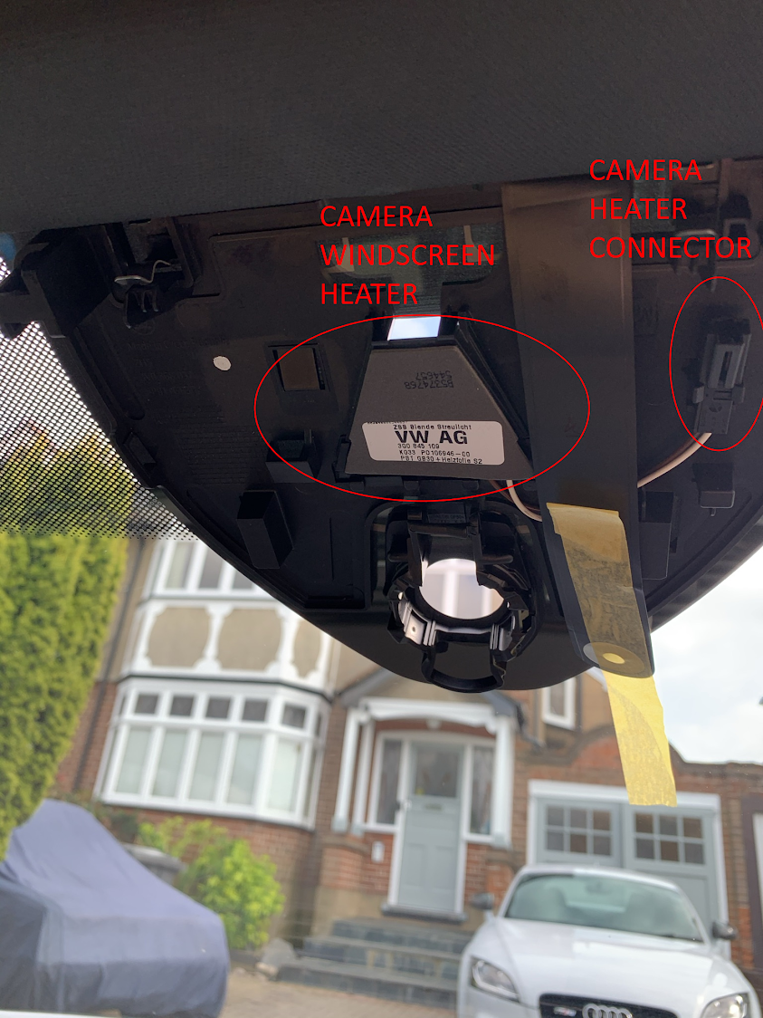](http://redirect.viglink.com/?key=71fe2139a887ad501313cd8cce3053c5&subId=6321844&u=https%3A//ibb.co/n3m5GgD)
7. Connect the brown wire to the ground bolt in the light dome, the 2-pin connector to the camera heater on the windscreen, do not install the camera and connect the 12-pin connector (T8ay) to it for now (wait till the end).[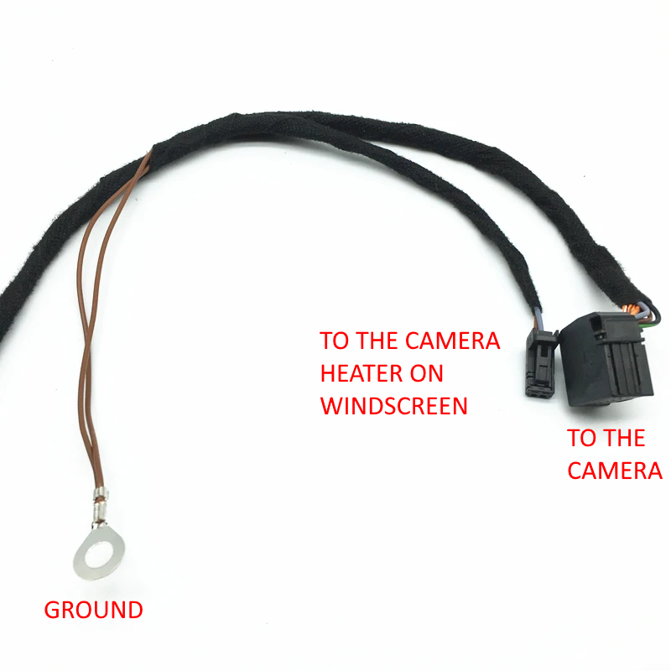](http://redirect.viglink.com/?key=71fe2139a887ad501313cd8cce3053c5&subId=6321844&u=https%3A//ibb.co/MVyJ791)

|  |  |
| --- | --- |
|  |  |

1. Run the wiring harness to the fuse box near the driver seat, passing it inside the roof, down the upper A-pillar and zip tying it to existing cables (to get an idea you can watch <https://www.youtube.com/watch?v=SSNWBijc8mg> and <https://www.youtube.com/watch?v=vRzV4vKY1r4>).  
   Connect the black green wire using a mini fuse tap to SC32 fuse or if unable due to space to another fuse in the same row (<https://www.youtube.com/watch?v=59uL9jNEI1k>).  
   [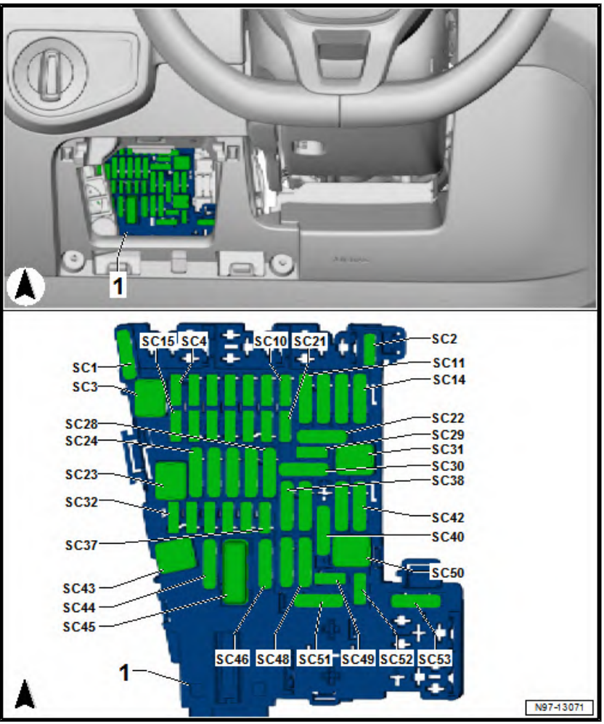](http://redirect.viglink.com/?key=71fe2139a887ad501313cd8cce3053c5&subId=6321844&u=https%3A//ibb.co/HKZTyzC)
2. Run the wiring harness to the TUIL connector in the lower A-pillar, take out the T17d/l female black connector (pull first the upper red clip on the top to allow removal).

[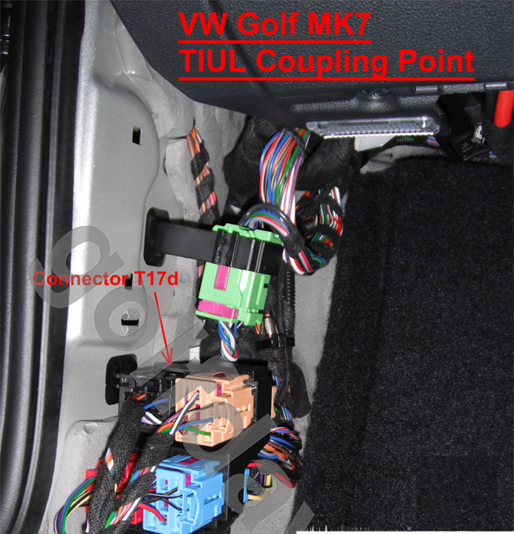](http://redirect.viglink.com/?key=71fe2139a887ad501313cd8cce3053c5&subId=6321844&u=https%3A//ibb.co/BZfzPzP)

[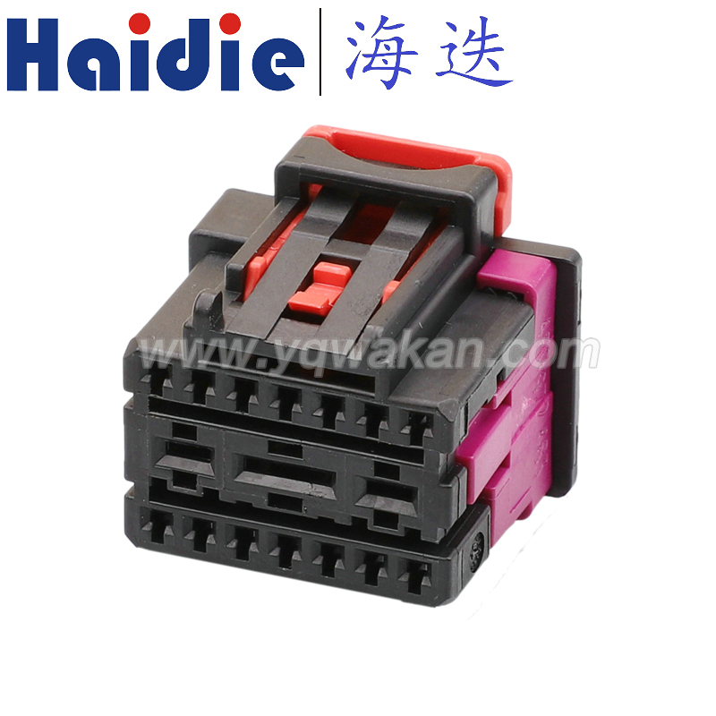](http://redirect.viglink.com/?key=71fe2139a887ad501313cd8cce3053c5&subId=6321844&u=https%3A//ibb.co/7bdcg8D)

You have then to de-pin pin 12 and 13 using the car terminal removal tools after having unlocked the purple lock on the connector (please see <https://www.youtube.com/watch?v=5rlXZUvhEsQ>)  
[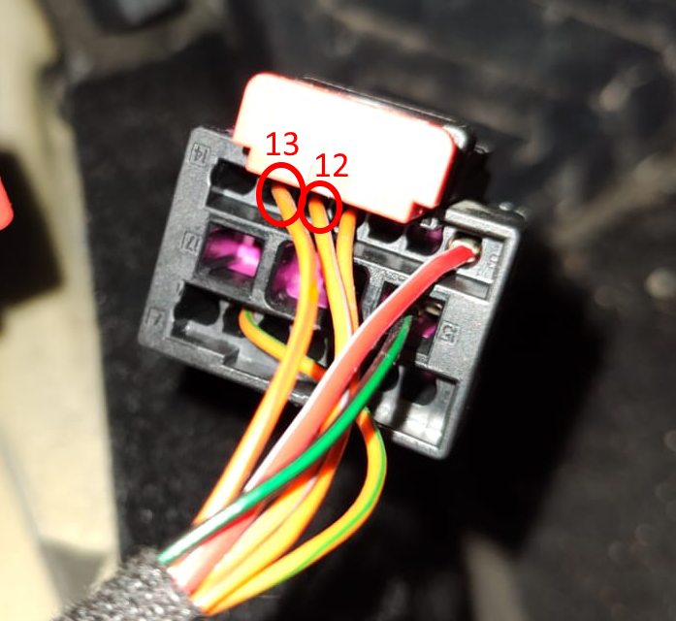](http://redirect.viglink.com/?key=71fe2139a887ad501313cd8cce3053c5&subId=6321844&u=https%3A//ibb.co/MMQBcFz)

You have to connect these two pins to the empty 2 pin connector provided with the wiring harness and in turn connect the two nearby spare pins to the T17d/l black connector, you have to respect the electric diagram above (you can use the wire colors).  
[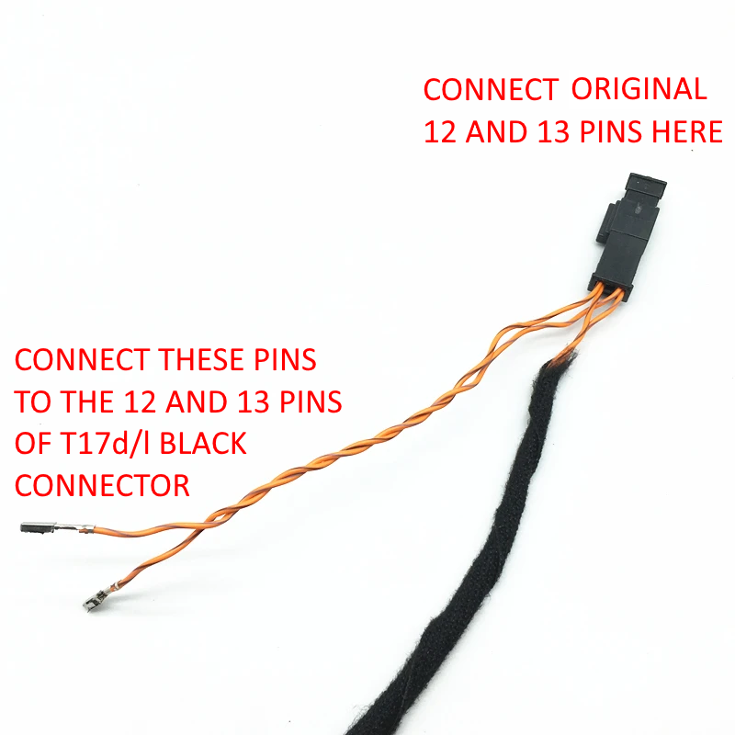](http://redirect.viglink.com/?key=71fe2139a887ad501313cd8cce3053c5&subId=6321844&u=https%3A//ibb.co/mhrzr1v)

Final result  
  
[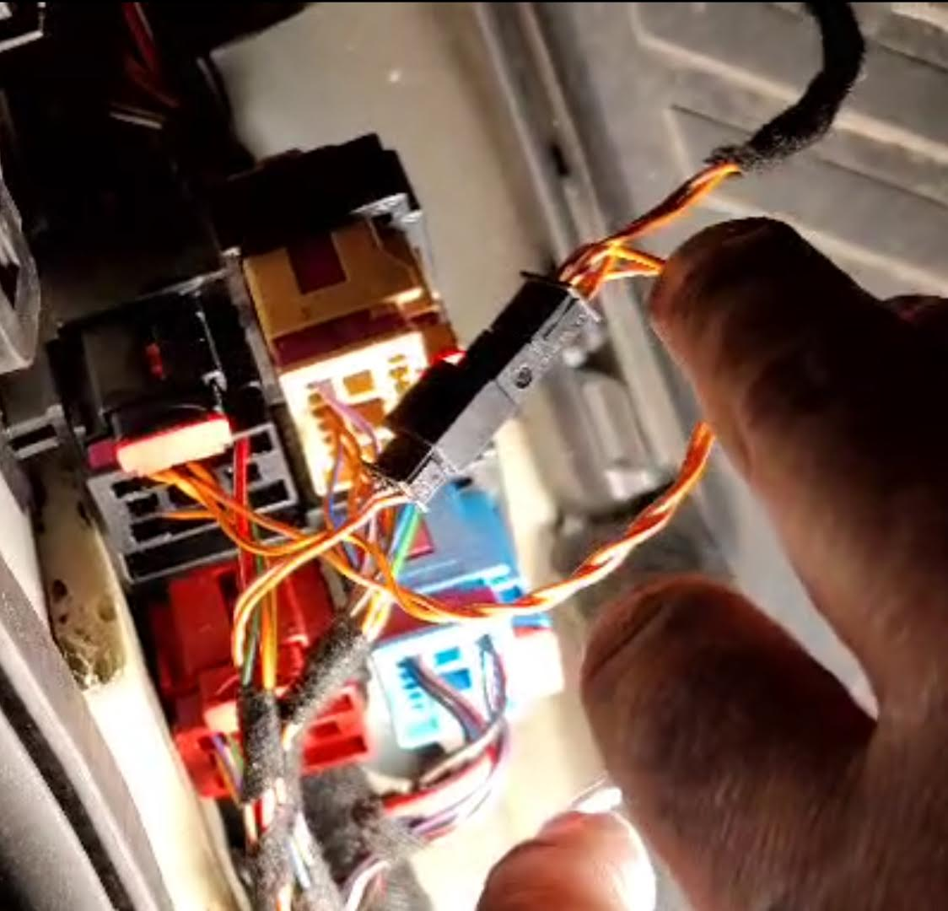](http://redirect.viglink.com/?key=71fe2139a887ad501313cd8cce3053c5&subId=6321844&u=https%3A//ibb.co/vX8Xqw6)  
  
This is the most critical connection point, in order to avoid issues in your car you must double check the connection with a tester, you can use a sewing pin to probe pins of a female connector:

* + Test that the original CAN bus line is not broken, e.g.
    - Test that the original orange-grey cable plugged into the above empty connector is still connected to pin 12 of the T17d/l black connector
    - Test that the original orange-brown cable plugged into the above empty connector is still connected to pin 13 of the T17d/l black connector
  + Test that the lane assist camera connection is fine, e.g.
    - Test that pin 8 of the lane assist camera connector on the windscreen is connected to pin 12 of the T17d/l black connector
    - Test that pin 2 of the lane assist camera connector on the windscreen is connected to pin 13 of the T17d/l black connector

Camera connector near camera support on the windscreen  
[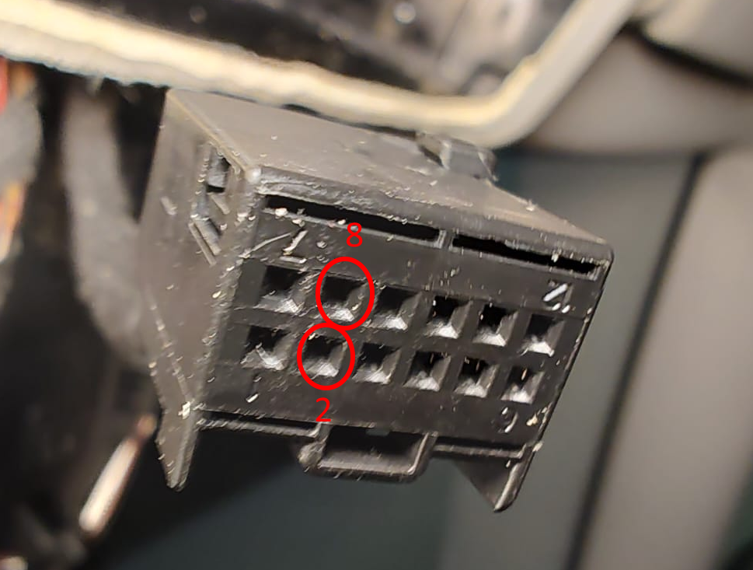](http://redirect.viglink.com/?key=71fe2139a887ad501313cd8cce3053c5&subId=6321844&u=https%3A//ibb.co/fq83wGF)

1. If you have adaptive cruise control you must also:
   * Remove the battery
   * Remove the adaptive cruise control grille (<https://www.youtube.com/watch?v=2XAw_byXNFM>)
   * Connect the two additional wires (orange/white and orange/brown) of the lane assist wiring harness to adaptive cruise control connector in the engine bay (orange/white wire to pin 5, orange/brown wire to pin 6): to run the 2 wire twisted cable (do not untwist it!) from vehicle cabin into engine bay you can punch the rubber grommet above the clutch pedal and you will come out just behind the battery (please see [www.autoinstruct.com.au/manufacturer/volkswagen/mk7-golf/running-cables-through-the-firewall/](http://redirect.viglink.com/?key=71fe2139a887ad501313cd8cce3053c5&subId=6321844&u=https%3A//www.autoinstruct.com.au/manufacturer/volkswagen/mk7-golf/running-cables-through-the-firewall/) and <https://www.youtube.com/watch?v=j_DoT6AGn8E&t=8s>, <https://www.youtube.com/watch?v=W8Pnv8okMe4>). You can run the wire down under the right side of the battery, come near the right headlight and finally along under the adaptive cruise control grille. I strongly advise however to tape the last part of the 2 wire twisted cable with wiring harness tape in order to make it more water resistant (water o rain can come in from the front grille). To insert new pins inside the ACC connector you have first to unlock it by sliding the green lock (there are 2 green locks, one of each row of pins).  
     [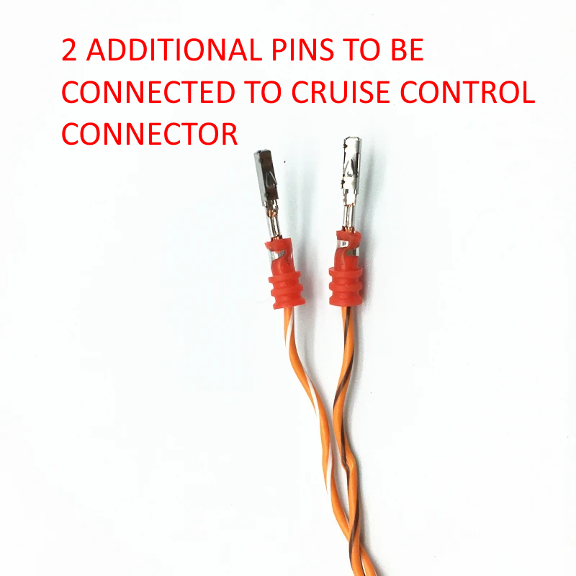](http://redirect.viglink.com/?key=71fe2139a887ad501313cd8cce3053c5&subId=6321844&u=https%3A//ibb.co/QrQ3Bv8)  
     [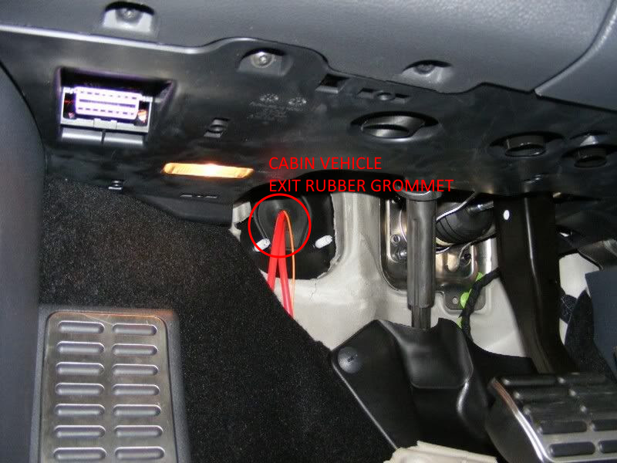](http://redirect.viglink.com/?key=71fe2139a887ad501313cd8cce3053c5&subId=6321844&u=https%3A//ibb.co/G3XRzNd)  
     [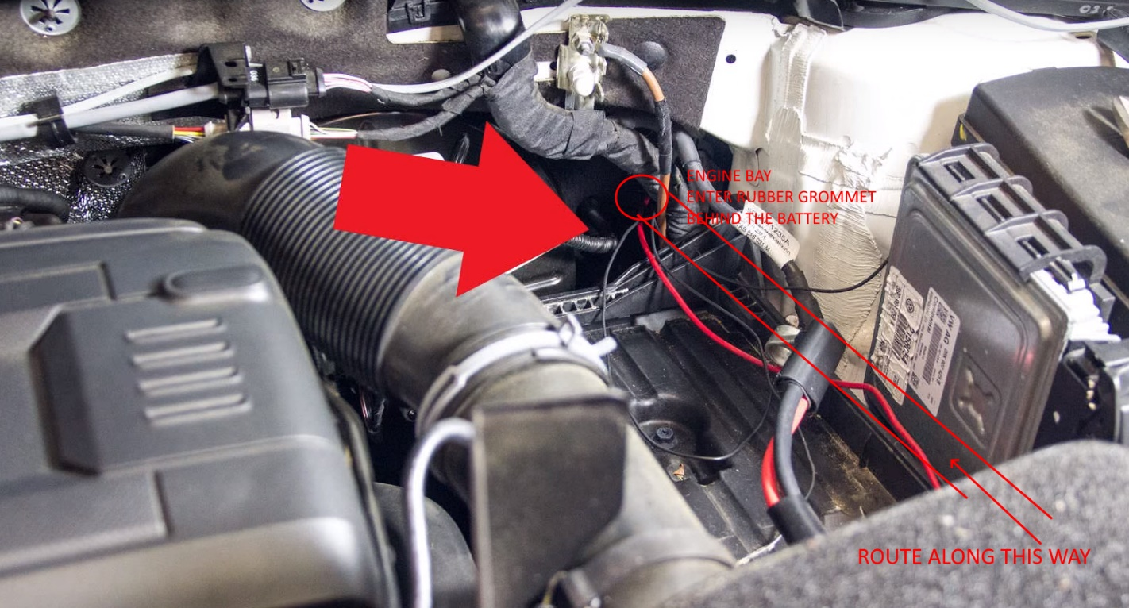](http://redirect.viglink.com/?key=71fe2139a887ad501313cd8cce3053c5&subId=6321844&u=https%3A//ibb.co/t8F8Qrr)  
       
     [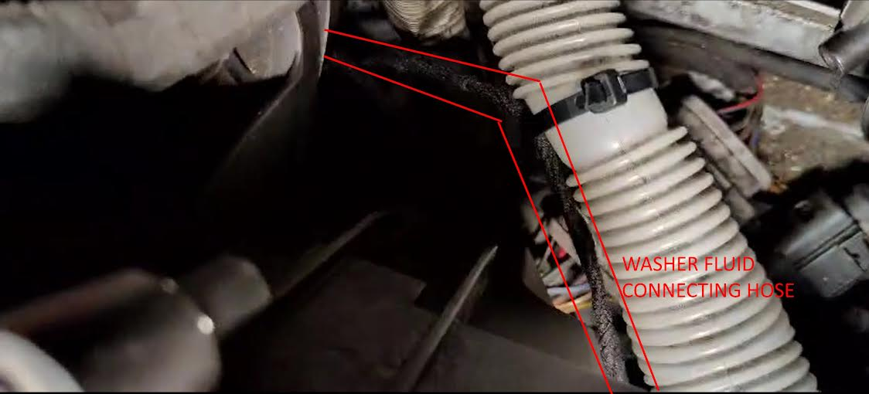](http://redirect.viglink.com/?key=71fe2139a887ad501313cd8cce3053c5&subId=6321844&u=https%3A//ibb.co/gS8p66B)  
       
     [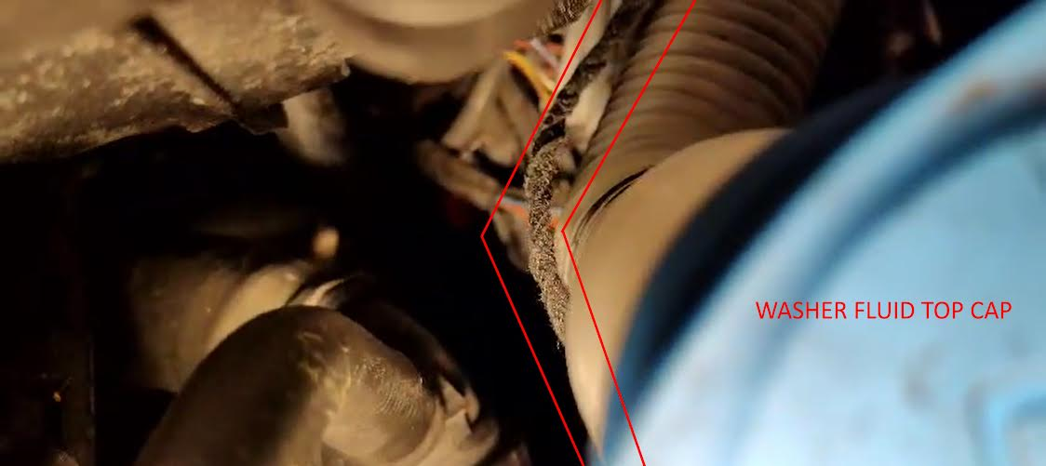](http://redirect.viglink.com/?key=71fe2139a887ad501313cd8cce3053c5&subId=6321844&u=https%3A//ibb.co/DbxdR7D)  
     [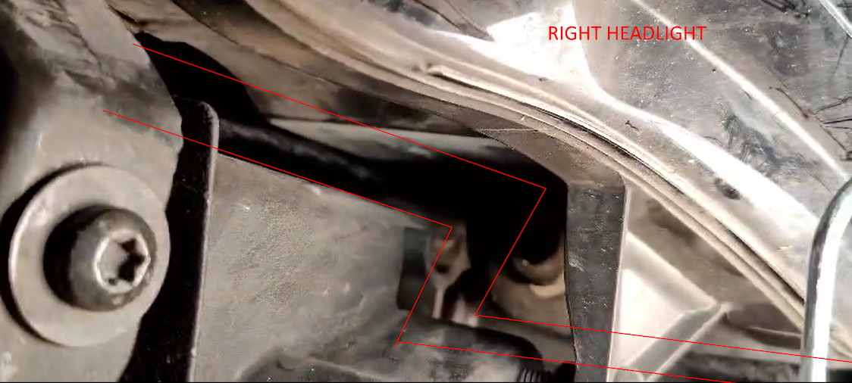](http://redirect.viglink.com/?key=71fe2139a887ad501313cd8cce3053c5&subId=6321844&u=https%3A//ibb.co/wRDDVqh)  
       
     [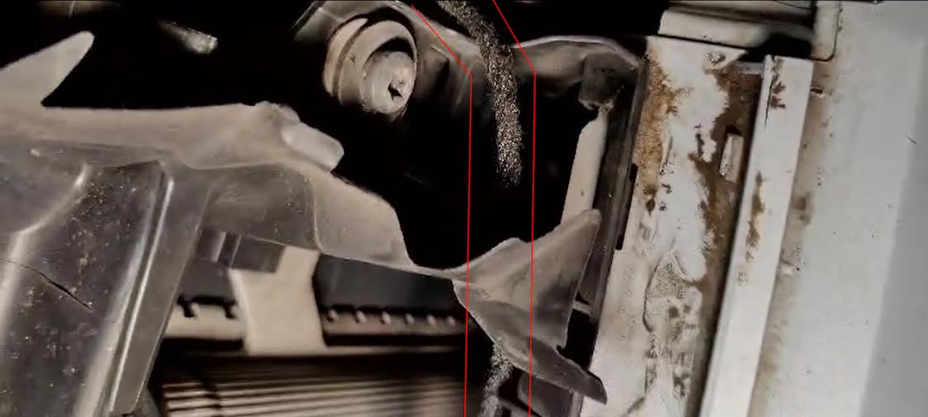](http://redirect.viglink.com/?key=71fe2139a887ad501313cd8cce3053c5&subId=6321844&u=https%3A//ibb.co/kJ8HNWW)  
       
     [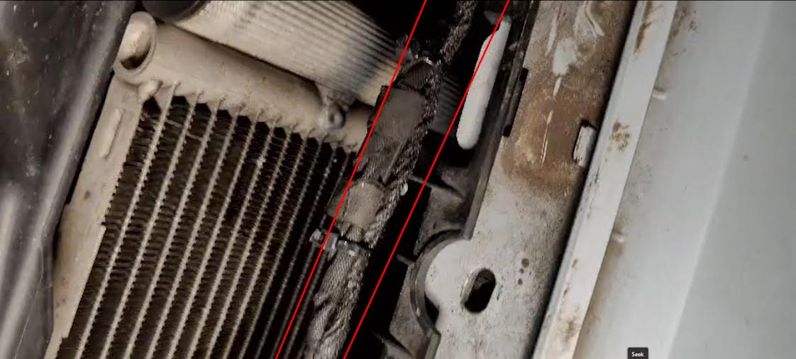](http://redirect.viglink.com/?key=71fe2139a887ad501313cd8cce3053c5&subId=6321844&u=https%3A//ibb.co/6D3XGL8)  
     [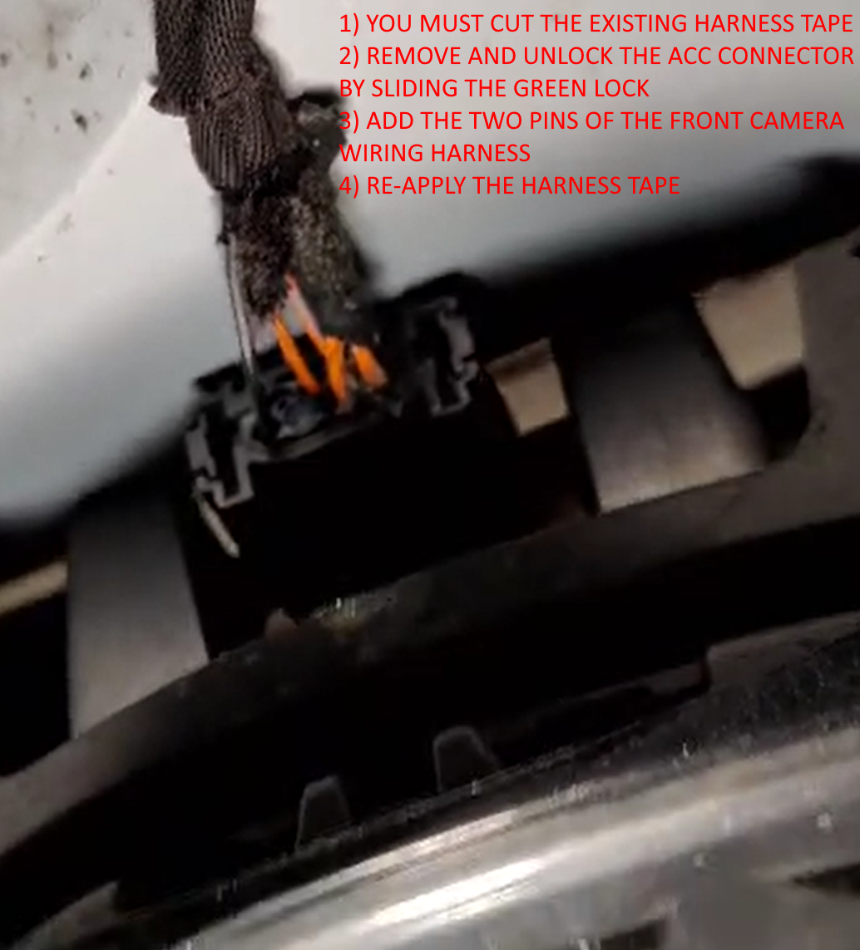](http://redirect.viglink.com/?key=71fe2139a887ad501313cd8cce3053c5&subId=6321844&u=https%3A//ibb.co/XWhBxjJ)  
     [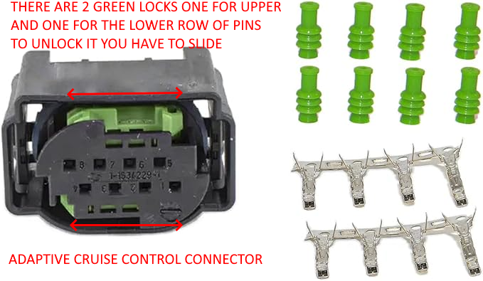](http://redirect.viglink.com/?key=71fe2139a887ad501313cd8cce3053c5&subId=6321844&u=https%3A//ibb.co/1rqMrPF)

Well done, you have almost finished the retrofitting, you still need to:

* Do the coding using OBD11 or any tool you have (you can google for Xagico VW Golf MkVII pdf)
* Check that A5 control unit has only 2 faults "No Basic Setting" and the obvious component protection (CP) due to the new control unit, both these errors will be solved after having done the calibration procedure
* Perform ADAS calibration (front camera, adaptive cruise control, etc.) at a local car glass center

All done!